**Lab-4**

**ARTIFICIAL INTELLIGENCE**



**Title:** - **The Block World Problem**

**Group Details:**

**Group No: TY-12 Div.: B Batch: B-3**

|  |  |  |  |
| --- | --- | --- | --- |
| **Sr.No** | **Name** | **Roll.No** | **Gr.No** |
| 1 | Shubham Kakde | 49 | 11811244 |
| 2 | Sidharth Kakde | 50 | 11811170 |
| 3 | Vedant Katti | 55 | 11810142 |
| 4 | Vinayak Kokane | 58 | 11810499 |
| 5 | Dhanraj Kore | 60 | 11810970 |

**Implementation:**

#!/usr/bin/env python

# coding: utf-8

# In[1]:

import sys

#Some lists required for algorithm

start_state = [] #required for storing initial state

goal_state = []  #required for storing final state

current_state = [] #required for storing current ongoing state

planning_stack = [] #stack required in goal stack planning (only going to add sub goals)

actual_plan = []  #plan generated (output)

#actions and predicates

actions = ["stack", "unstack", "pickup", "putdown"]

predicates = ["on", "clear", "arm_empty", "holding", "on_table"]

#necessary functions required for algorithm

#Preconditions append functions:-

def preconditions_stack(X, Y):

    planning_stack.append("holding "+str(X))

    planning_stack.append("clear "+str(Y))

def preconditions_unstack(X, Y):

    planning_stack.append("on "+str(X)+" "+str(Y))

    planning_stack.append("clear "+str(X))

def preconditions_pickup(X):

    planning_stack.append("arm_empty")

    planning_stack.append("on_table "+str(X))

    planning_stack.append("clear "+str(X))

def preconditions_putdown(X):

    planning_stack.append("holding "+str(X))

#Corresponding action required to satisfy the predicates

def for_on(X, Y):

    planning_stack.append("stack "+str(X)+" "+str(Y))

    preconditions_stack(X, Y)

def for_ontable(X):

    planning_stack.append("putdown "+str(X))

    preconditions_putdown(X)

def for_clear(X):

    #Finding the block on which X is stacked

    check = "on "

    for predicate in current_state:

        if check in predicate:

            temp_list = predicate.split()

            if temp_list[2] == X:

                break

    Y = str(temp_list[1])

    #Appending Unstack operatrion

    planning_stack.append("unstack "+str(Y)+" "+str(X))

    preconditions_unstack(Y, X)

def for_holding(X):

    check = "on_table "+str(X)

    if check in current_state:

        planning_stack.append("pickup "+str(X))

        preconditions_pickup(X)

    else:

         #Finding the block on which X is stacked

        check = "on "

        for predicate in current_state:

            if check in predicate:

                temp_list = predicate.split()

                if temp_list[2] == X:

                    break

        Y = str(temp_list[1])

        #Appending Unstack operatrion

        planning_stack.append("unstack "+str(Y)+" "+str(X))

        preconditions_unstack(Y, X)

def for_armempty():

    print("\nArm empty predicate false\n")

    sys.exit()

#Effects of action

def effect_stack(X, Y):

    current_state.remove("holding "+str(X))

    current_state.remove("clear "+str(Y))

    current_state.append("on "+str(X)+" "+str(Y))

    current_state.append("clear "+str(X))

    current_state.append("arm_empty")

def effect_unstack(X, Y):

    current_state.remove("on "+str(X)+" "+str(Y))

    current_state.remove("clear "+str(X))

    current_state.remove("arm_empty")

    current_state.append("holding "+str(X))

    current_state.append("clear "+str(Y))

def effect_pickup(X):

    current_state.remove("arm_empty")

    current_state.remove("on_table "+str(X))

    current_state.remove("clear "+str(X))

    current_state.append("holding "+str(X))

def effect_putdown(X):

    current_state.remove("holding "+str(X))

    current_state.append("arm_empty")

    current_state.append("on_table "+str(X))

    current_state.append("clear "+str(X))

# ## Actual Algorithm

#

# while stack is not empty:<br>

# &emsp;if top of stack is predicate:<br>

# &emsp;&emsp;if predicate is true:<br>

# &emsp;&emsp;&emsp;pop it<br>

# &emsp;&emsp;else: <br>

# &emsp;&emsp;&emsp;pop it<br>

# &emsp;&emsp;&emsp;push corresponding action that will satisfy that predicate onto stack<br>

# &emsp;&emsp;&emsp;push preconditions of that action<br>

# &emsp;if top of stack is action:<br>

# &emsp;&emsp;pop it<br>

# &emsp;&emsp;perform the action i.e add and delete it's effects from current state.<br>

# &emsp;&emsp;add that action to the actual plan   <br>

# In[ ]:

input_string = input("Enter start state:- ")

start_state = input_string.split("^")

input_string = input("Enter goal state:- ")

goal_state = input_string.split("^")

print("\nEntered Start State:- "+str(start_state))

print("\nEntered Goal State:- "+str(goal_state)+"\n")

current_state = start_state.copy()

for predicate in goal_state:

    planning_stack.append(predicate)

while len(planning_stack) > 0:

    print("Planning Stack:- "+str(planning_stack))

    print("Current State:- "+str(current_state)+"\n")

    top = planning_stack.pop()

    temp = top.split()

    if temp[0] in predicates: #if top of stack is predicate

        if top in current_state: #if predicate is true:

            continue #You have already poped it.

        else:

            #Already poped above

            #push corresponding action that will satisfy that predicate onto stack and push preconditions of that action

            if temp[0] == "on":

                for_on(temp[1], temp[2])

            elif temp[0] == "on_table":

                for_ontable(temp[1])

            elif temp[0] == "clear":

                for_clear(temp[1])

            elif temp[0] == "holding":

                for_holding(temp[1])

            elif temp[0] == "arm_empty":

                for_armempty()

    if temp[0] in actions: #if top of stack is action

        #Already poped above

        #perform the action i.e add and delete it's effects from current state

        if temp[0] == "stack":

            effect_stack(temp[1], temp[2])

        elif temp[0] == "unstack":

            effect_unstack(temp[1], temp[2])

        elif temp[0] == "pickup":

            effect_pickup(temp[1])

        elif temp[0] == "putdown":

            effect_putdown(temp[1])

        #add that action to the actual plan

        actual_plan.append(top)

print("Final Current State:- "+str(current_state))

print("\nPlan Generated:- \n")

for step in actual_plan:

    print(step)

# In[ ]:

#Question

#Initial : on B A^on_table A^clear B^on C D^on_table D^clear C^arm_empty

#Goal : on A B^on_table B^clear A^on D C^on_table C^clear D^arm_empty

# In[ ]:

**Problem:**

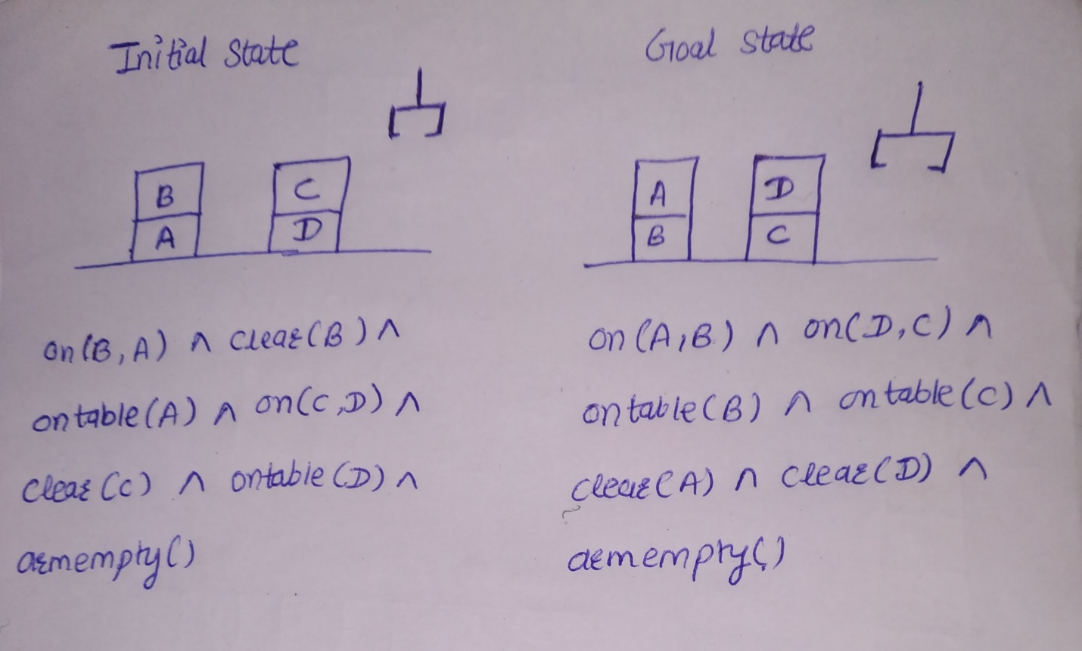

**O/P:**

